In Retrospect
April 13, 2025
#3 Vermont Coppers

In the Spring 2002 issue of the C4 Newsletter, Marc Mayhugh broadened our introduction to the New York City silversmithing and coining partnership of Daniel Van Voorhis and William Coley (“Van Voorhis & Coley: Silversmiths,” p. 21-6). Coley would later move to the wilds of Rupert, Vermont, and was involved in the production of Vermont Coppers at Reuben Harmon’s mint. He is credited as being the engraving artist behind the design of the magnificent Landscape dies (upon which the seal of the Colonial Coin Collectors Club is derived). A decade later, Mayhugh wrote about Coley again in his article “William Coley: A Brief Biography of a Colonial Minter,” which appeared in the Spring 2012 Newsletter.
In 2016, present C4 President Christopher McDowell and numismatic scholar Gary Trudgen visited Coley’s, previously undocumented and sadly neglected grave in Otselic, New York. McDowell, Trudgen, members of the community, and the DAR, repaired the gravesite. The then C4 President Jim Rosen authorized a plaque that was installed to detail Coley’s importance to colonial numismatics. McDowell wrote about the graveside ceremony in the Summer 2016 Newsletter (“Colonel William H. Coley: Honoring an American Hero”). In the prior issue of the Newsletter (Spring 2016), McDowell had authored “Daniel Van Voorhis: New York City Coiner,” an exemplary article that studied in detail Coley’s involvement with the silversmithing and minting operations of Van Voorhis.

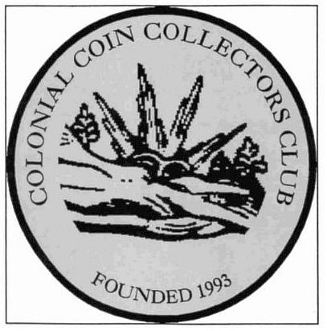
The C4 seal is based on Coley’s attributed Vermont Landscape die. This image is scanned from the cover of the Christmas 1994 Newsletter, in which the seal appeared for the first time as the official logo for the club. In the September 1994 Newsletter, then club president Angel Pietri announced a “C4 Club Logo Design Contest,” and Gary Trudgen provided this winning design.
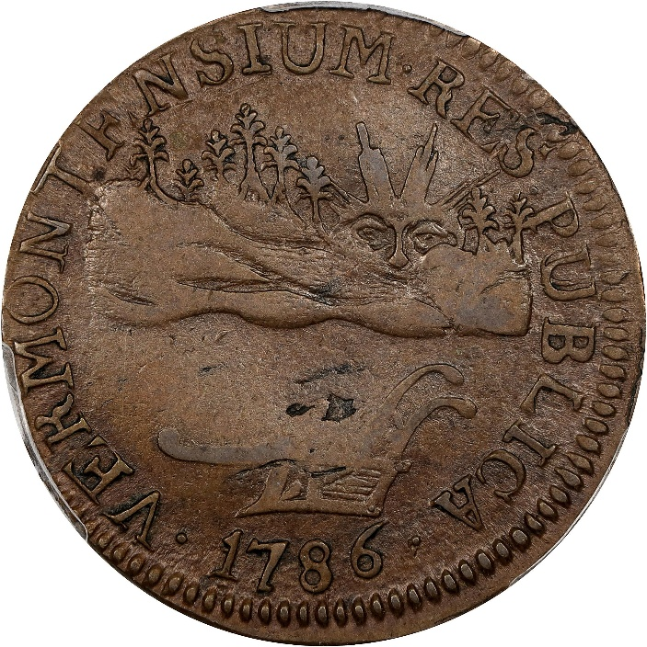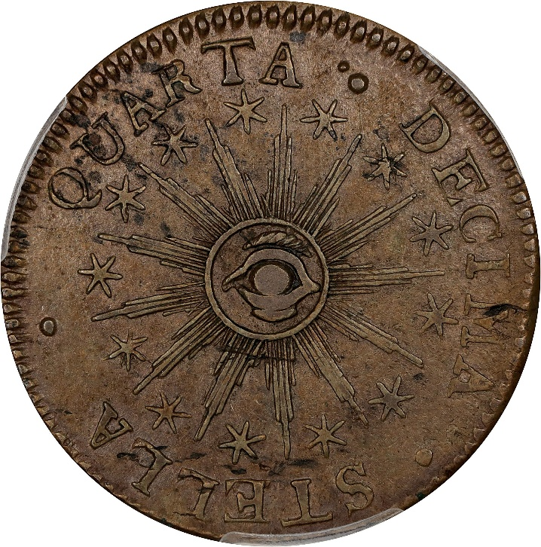
1786 Vermont Copper. Landscape. RR-7, Bressett 5-E, W-2025. Rarity-3. VERMONTENSIUM. AU-50 (PCGS). From the Stack’s Bowers Galleries sale of the Sydney F. Martin collection, August 2023, lot 8386.

