In Retrospect
June 8, 2025
#7 The CNL Research Forum and the Motts Storecard
In The Colonial Newsletter, No. 9 (August 1963), editor Jim Spilman inaugurated the RESEARCH FORUM as a way to combat “Two of the major roadblocks to researchers in the field of Colonial Numismatics.” These being, “the difficulties associated with identification of original sources of data and obtaining details regarding scarce specimens.” The Research Forum became a regular feature of the CNL for the next forty years.
Readers were invited to submit their requests or questions, which were then assigned an identification (RF) number. In the April 1999 CNL, Spilman, then Editor Emeritus, wrote “The Research Forum Revisited (Part I),” which republished the first twelve RF entries and noted that “Many responses to these Research Forum questions have been received and published over the years,” yet “many of these early questions have not elicited a single reply or comment!”
RF-1 was one of the questions that had slipped by without much notice. It was a simple question about the 1789-dated storecard for the Mott watchmaking and jewelry shop in New York City. It read “Has anyone seen the Mott token with lettered edge?”
The only report of a lettered edge Mott token was in United States Storecards by Edgar H. Adams (1920). Adams No. 610 is “Motts Jewelers, Clocks and Watches. 1789. A tall clock. R. Eagle. Copper. Thick planchet.” No. 611 is an entry for the “Thin planchet” and no. 612 is the “Engrailed edge.” Adams no. 613 is the Motts storecard noted to have “Edge lettered PAYABLE AT LIVERPOOL, LONDON OR BRISTOL.”
That a Mott token with a lettered edge has not surfaced is unsurprising. Possibly, Adams made a mistake, since such edge lettering would imply the Mott token was made at the same time as the circa 1790s British trade tokens, i.e., “Conder” tokens. Indeed, most numismatic scholars now believe that the Mott token is better suited to have been minted in the early or early mid-nineteenth century, belying the 1789 date.
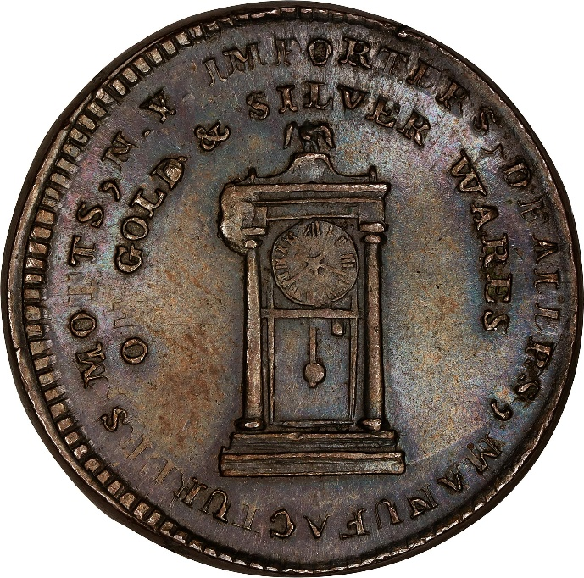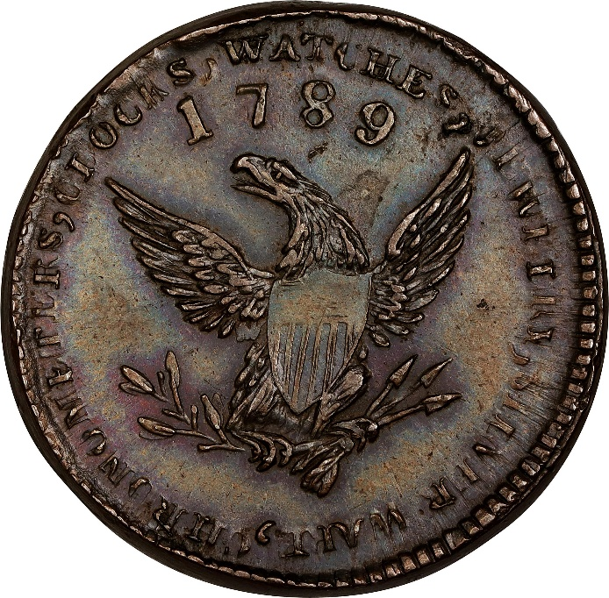
“1789” Mott Token. Breen-1022, Rulau-E NY 610. Thick Planchet. Plain Edge. Cent Weight. MS-63 BN (PCGS). 200.6 grains. An outstanding example of the type. Struck remarkably well from a fairly early state of the dies, this piece displays seldom seen detail on the clock and eagle motifs including all of the Roman numerals and hands on the clock face, as well as exceptional sharpness on the eagle and shield. Attractively toned surfaces with a patina of light olive-brown and steel-blue as well as traces of rose and violet. Mint frost is present on both sides and there is no trace of wear. Impressive quality throughout.
Provenance: From the Sydney F. Martin Collection. Earlier ex Lawrence R. Stack Collection, November 2006.
Image and description courtesy of Stack’s Bowers Galleries, Spring 2023. The Sydney F. Martin Collection, Part III, lot 1164.
